

**A**

**Grand Project**

**On**

**PETXHUB**

Submitted to

Gujarat University

Faculty of Computer Applications

*In partial fulfilment of the requirement of the award for the degree of Bachelor of*

*Computer Applications*



**Gujarat University**

**Under the guidance of**

***Faculty Name***

***(Vanita Mam)***

Submitted by

|  |  |
| --- | --- |
| NAME | ENROLMENT NUMBER |
| Ansh Anandani | 202112102062 |
| Pratham Lalwani | 202112102134 |
| Rahul Raghani | 202112102196 |

***DECLARATION***

*We,* ***“Ansh Anandani,*** ***Pratham Lalwani and Rahul Raghani”*** *hereby declare that*

*The report for Software Development Project part-II entitled* **PETXHUB** *is a result of our own work and our indebtedness to other work publications, references, if any, have been duly acknowledged.*

***Place: Ahmedabad***

***Date:***

*Name and Signature of External Supervisor*

*Name and Signature of Project Guide*

***CERTIFICATE***

*“This is to Certify that the following students of Asia Pacific BCA College of Computer*

*Applications, from BCA SEMESTER VI (TY BCA)have satisfactory completed Software Development Project –II On “***PETXHUB***”.*

*Dr. Bharti Vidhani Name and Signature of Project Guide Principal I/C*

|  |
| --- |
|  |

*Date:*

*Place:*

***PREFACE***

There is a famous saying “The theory without practical is lame and practical without theory is blind.”

*This project report is accompanied with practical experiences to add some worthiness to education. This practical in B.C.A program developer competencies of business world. Thus, we have a practical outlook of the managerial experts and witness the function of Computer Technology in real business.*

*My work in this project is, therefore, a humble attempt towards this end, In spite of my best efforts, there may be errors or omissions, which may please be excused.*

*This information furnished here is correct and true according to us.*

**COMPANY CERTIFICATE**

**COMPANY PROFILE**

|  |  |
| --- | --- |
| **Company Name** | INFOLABZ IT SERVICES PVT LTD |
| **Owner Name** | MR. CHINTAN NAGARECHA |
| **Website** | https://www.infolabz.in/ |
| **Address** | 405 Vraj Avenue, Above SAM'S Pizza, Nr Commerce Six  Road, Navrangpura, Ahmedabad, 380009 |
| **Contact No** | 8866662662 |
| **Description** | InfoLabz Pvt Ltd is one of the leading IT companies who provides technical solutions. We are involved in Web Development, App Development, Progressive Web Application Development, Corporate & Live project training and placement. |

***ACKNOWLEDGEMENT***

“The success of any person is not only his hard work but it is also the support and co*operation one gets for success”.*

*Apart from an individual effort, the success of any project depends largely on encouragement and guidelines of many others. We take this opportunity to express our gratitude to the people who have been instrumental in the successful completion of this project.*

My deep gratitude to everyone who gave their precious time by filling our survey and help us in successfully completing this project.

*I would also like to thank* ***Dr. Bharti Vidhani, Principal I/C,*** *for giving us a peaceful and calm atmosphere to help in our Study, and make this report.*

***Vanita Mam Faculty of Asia Pacific BCA College******GUIDE*** *who helped me with successful completion of project and give valuable suggestions and opinions for the project.*

*I express my Gratitude to the* ***Asia Pacific BCA College*** *support and the environment it has provided.*

**INDEX**

|  |  |  |
| --- | --- | --- |
| **Chapter No.** | **Title** | **Page No.** |
|  | Index Page | 01 |
|  | List of Figures | 02 |
|  | List of Tables | 03 |
| 1 | Company Profile | 04 |
| 2 | Project Profile   * 1. Project Summary   2. Project Profile   3. Objectives   4. Existing System   5. Proposed System   6. Tools & Technologies | 07 |
| 3 | System Flow Diagram | 20 |
| 4 | Data Flow Diagram   * 1. Context Level Diagram   2. DFD Level-1   3. DFD Leve1-2 | 23 |
| 5 | Entity Relationship Diagram | 39 |
| 6 | Data Dictionary | 43 |
| 7 | Conclusion | 61 |
| 8 | Bibliography | 63 |

**Screen Layouts**

* **Splash Screen :-**
* 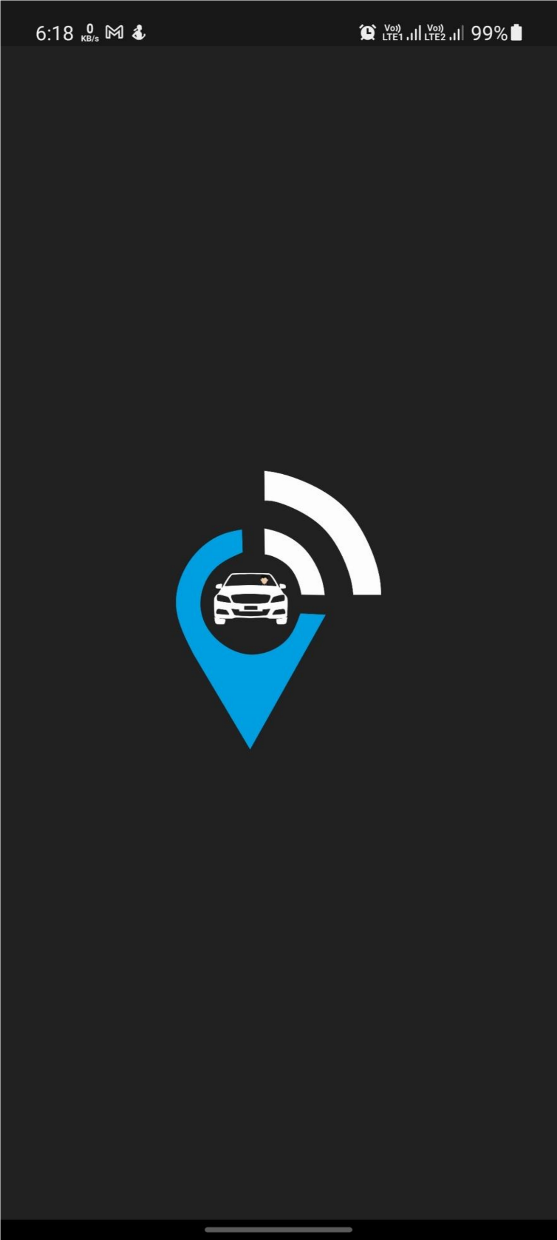
* **First Page :-**
* 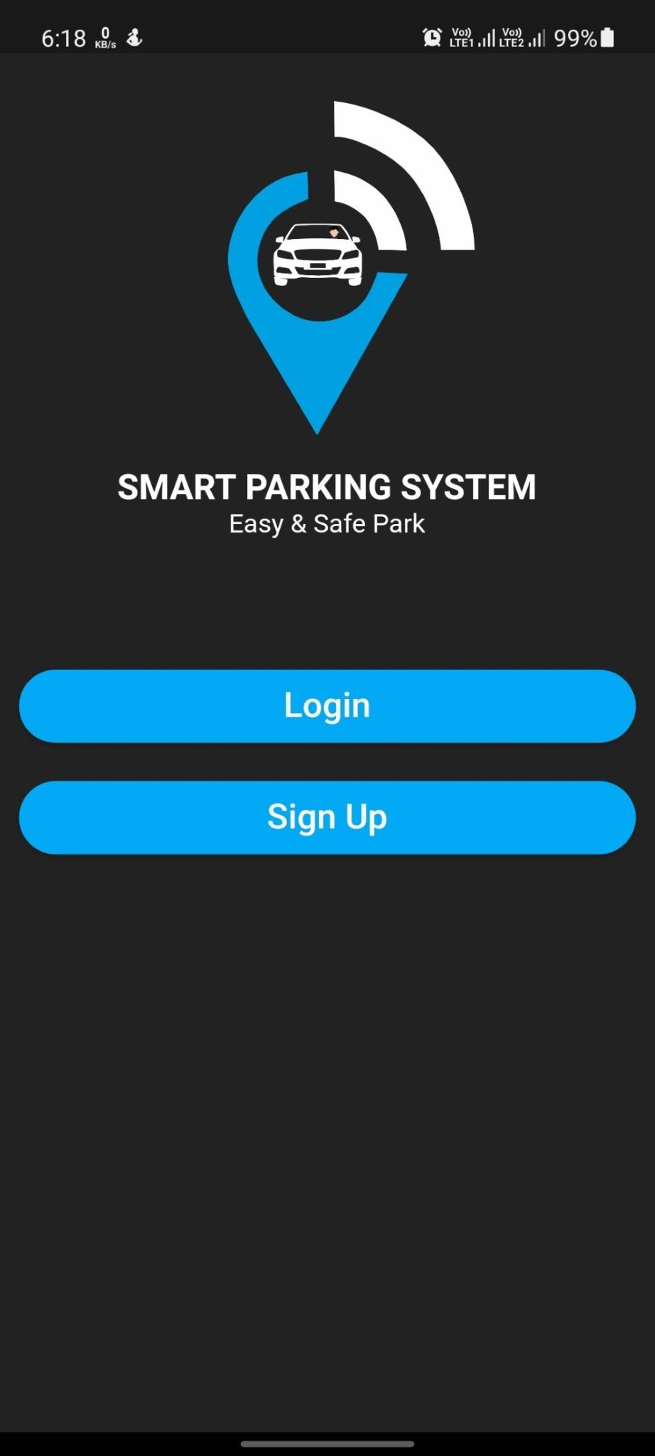

* **Login :-**

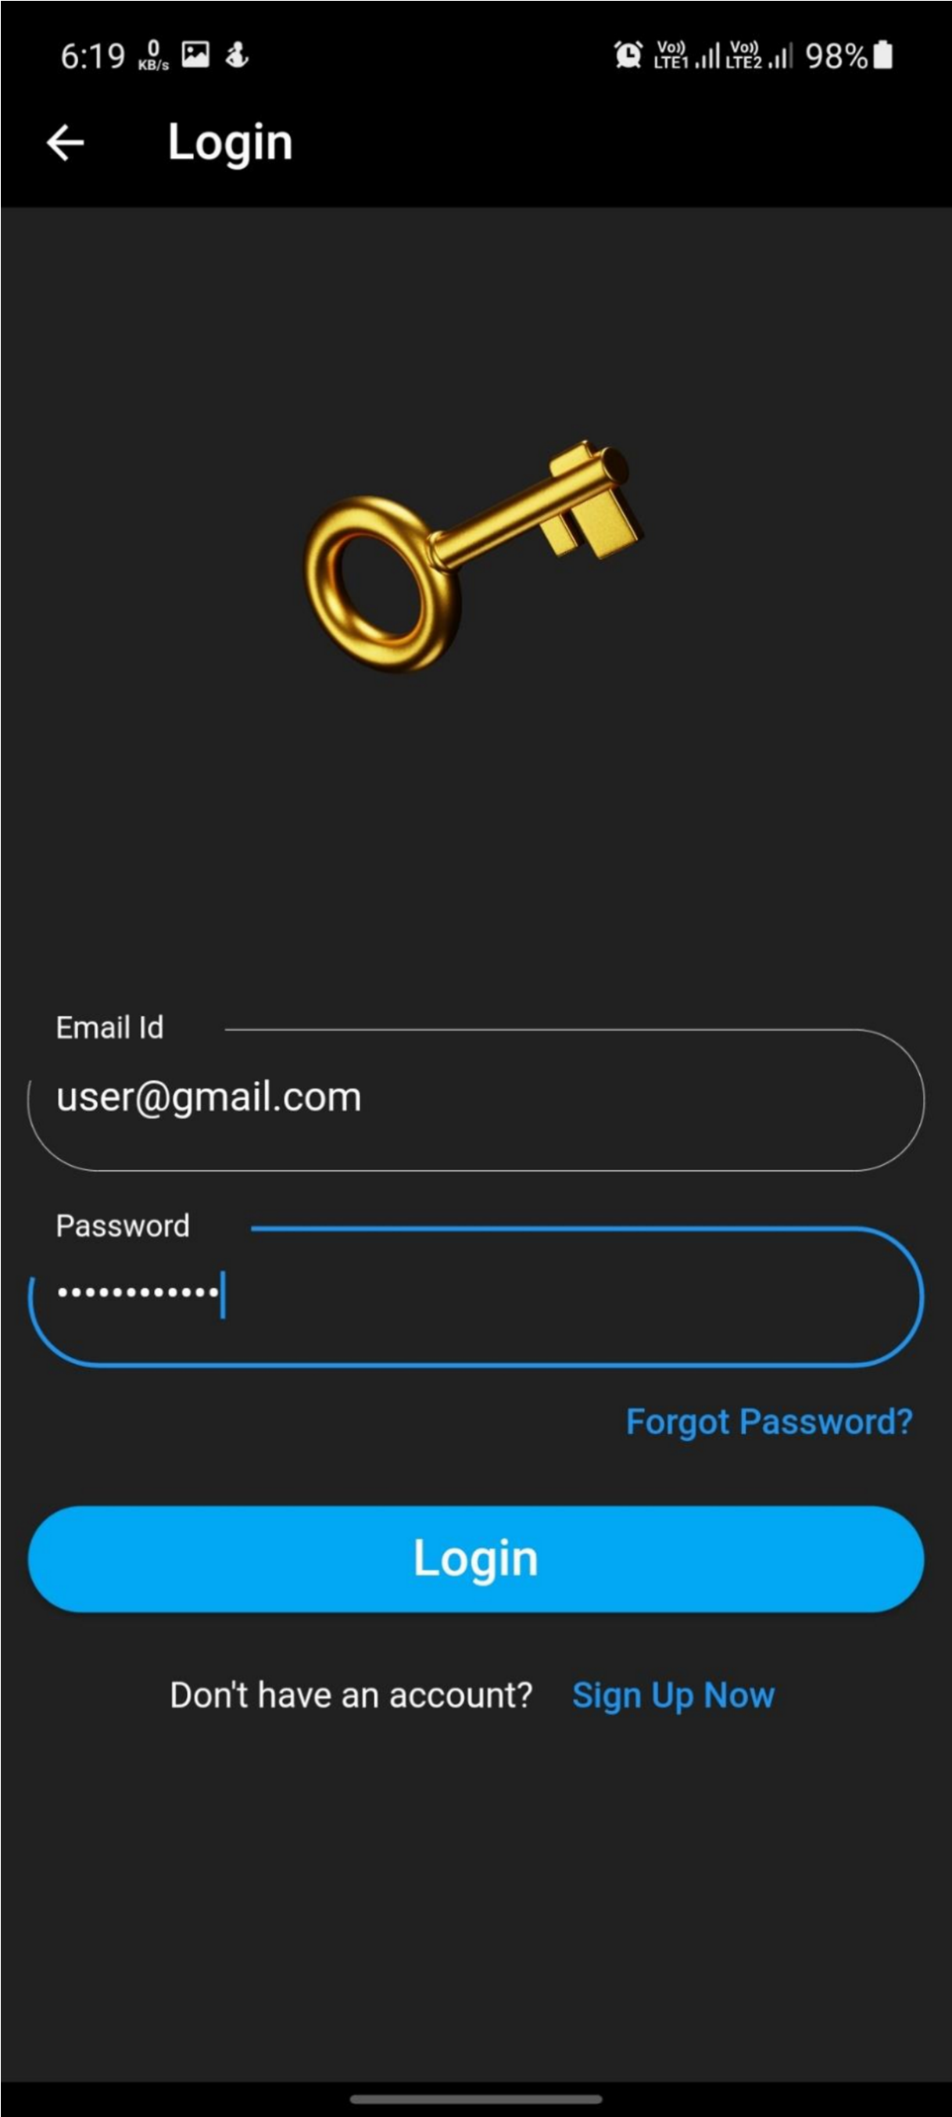

* **Signup :-**

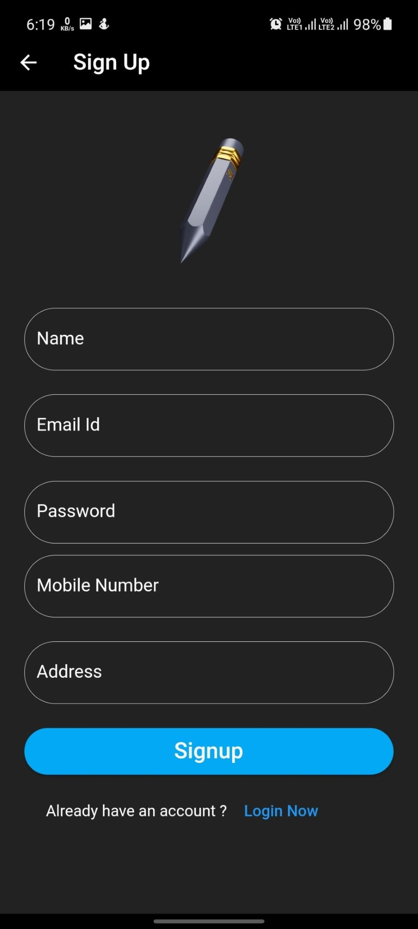

**HomePage :-**

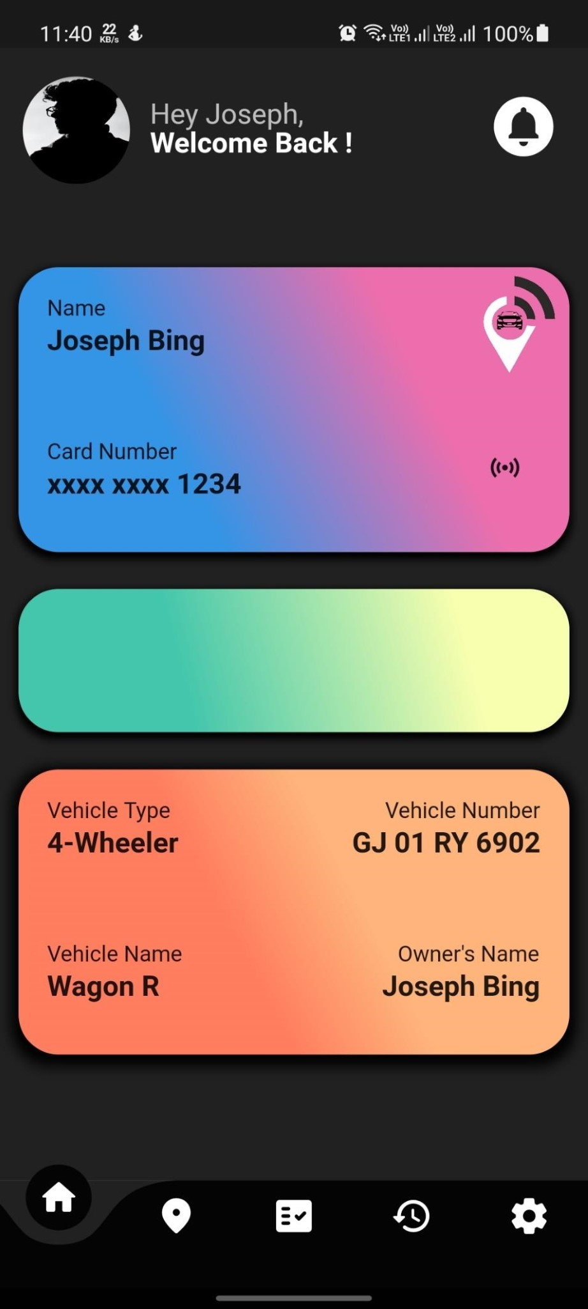

* **Location:-**

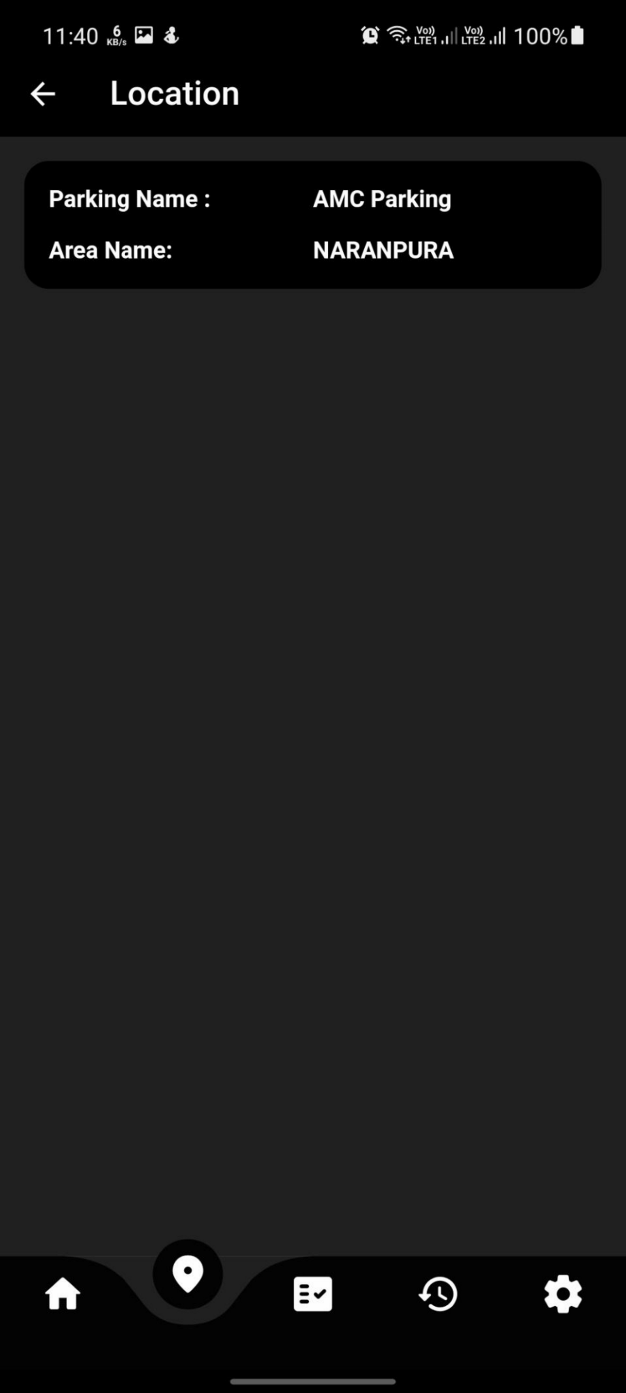

**Booking:-**

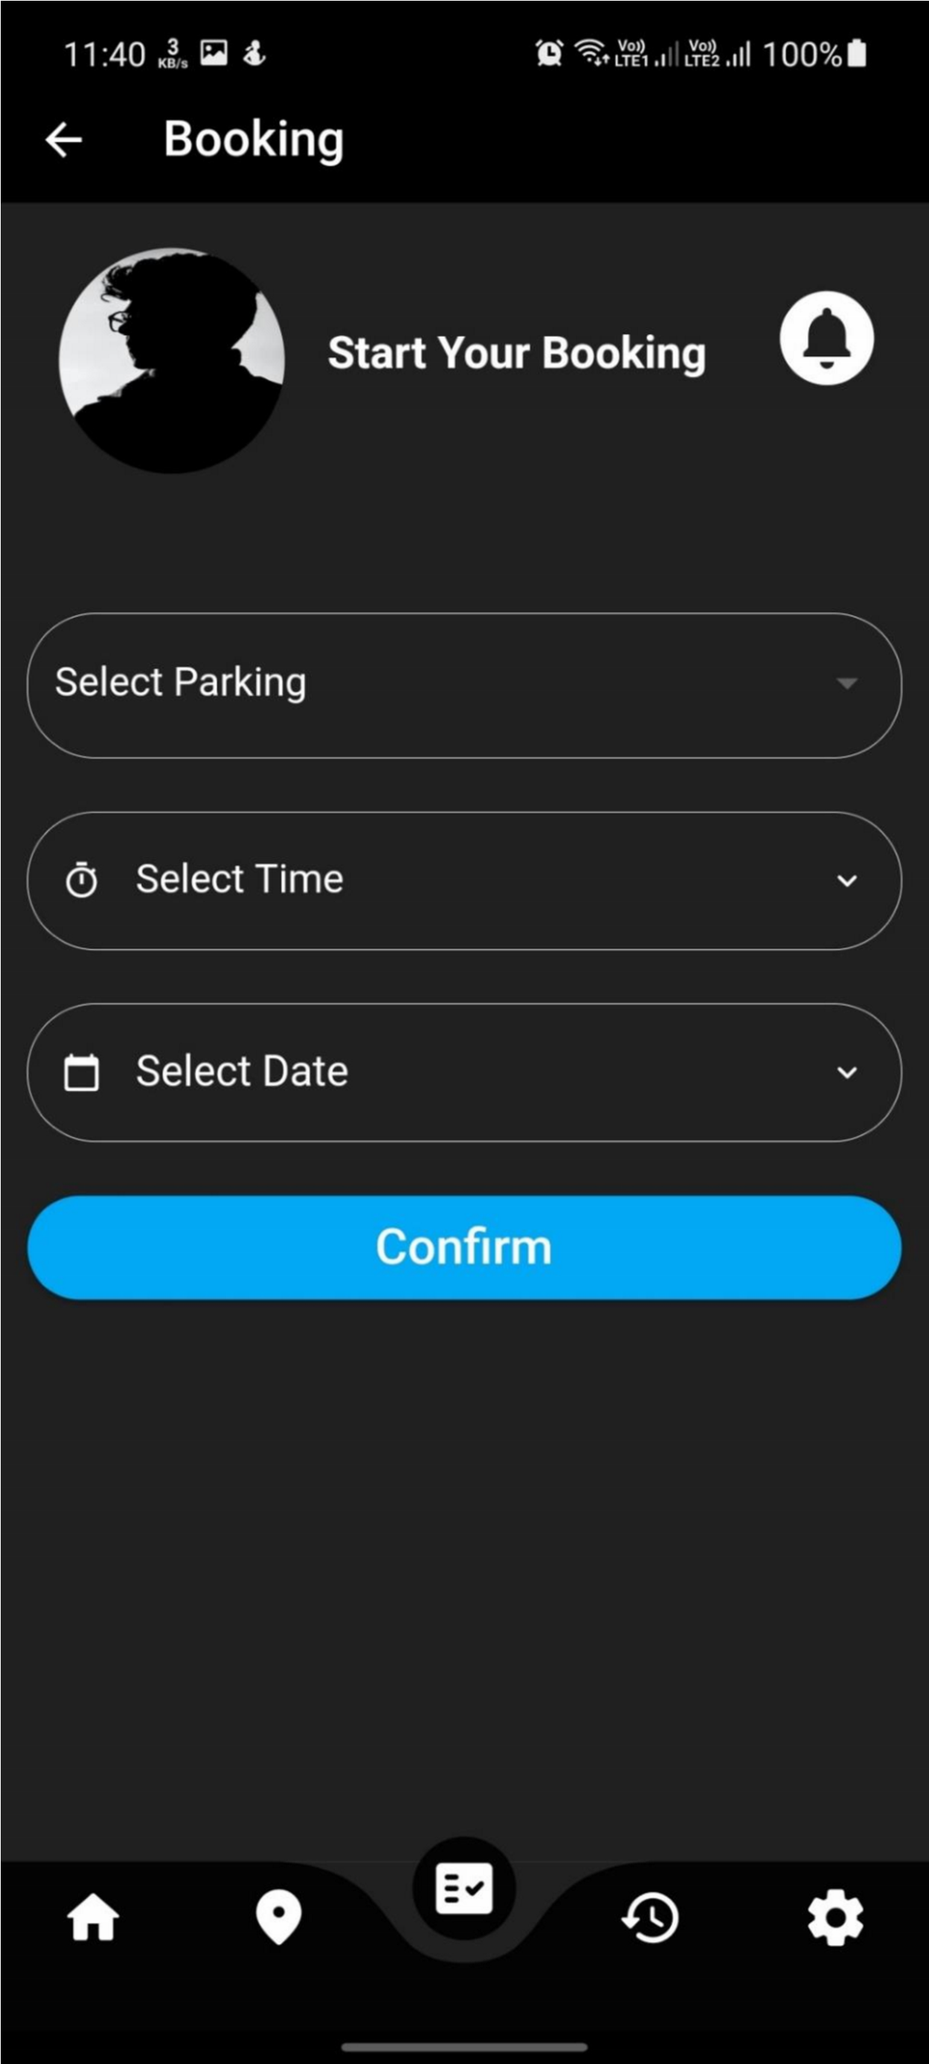

•

**History :**

**-**

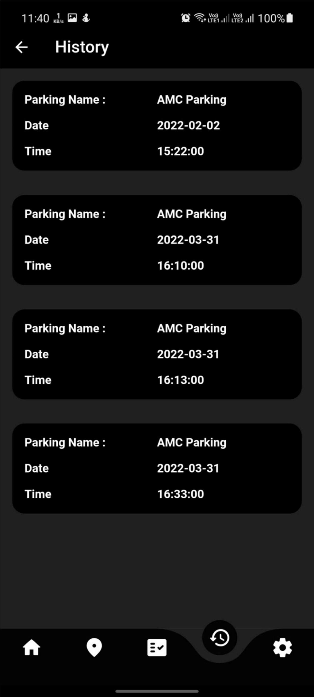

**Setting :**

**-**

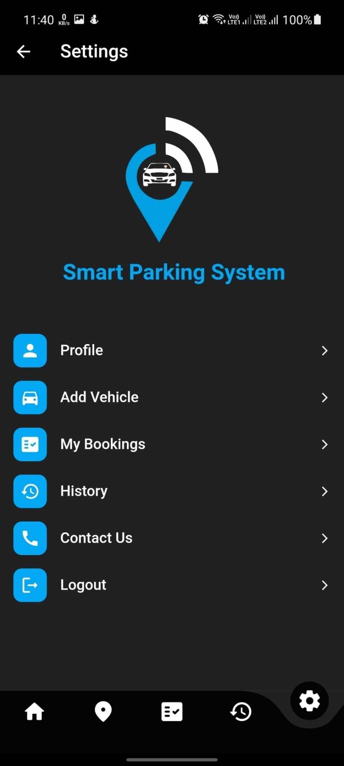

**Edit Profile:-**

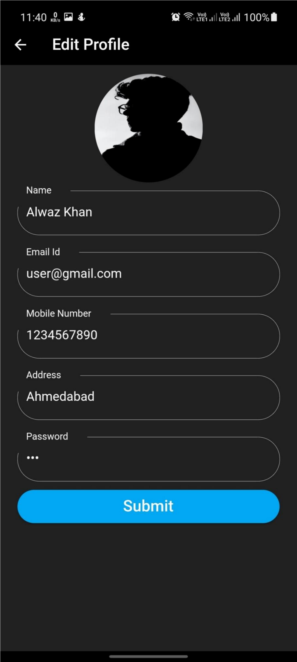

**Add Vehicle :-**

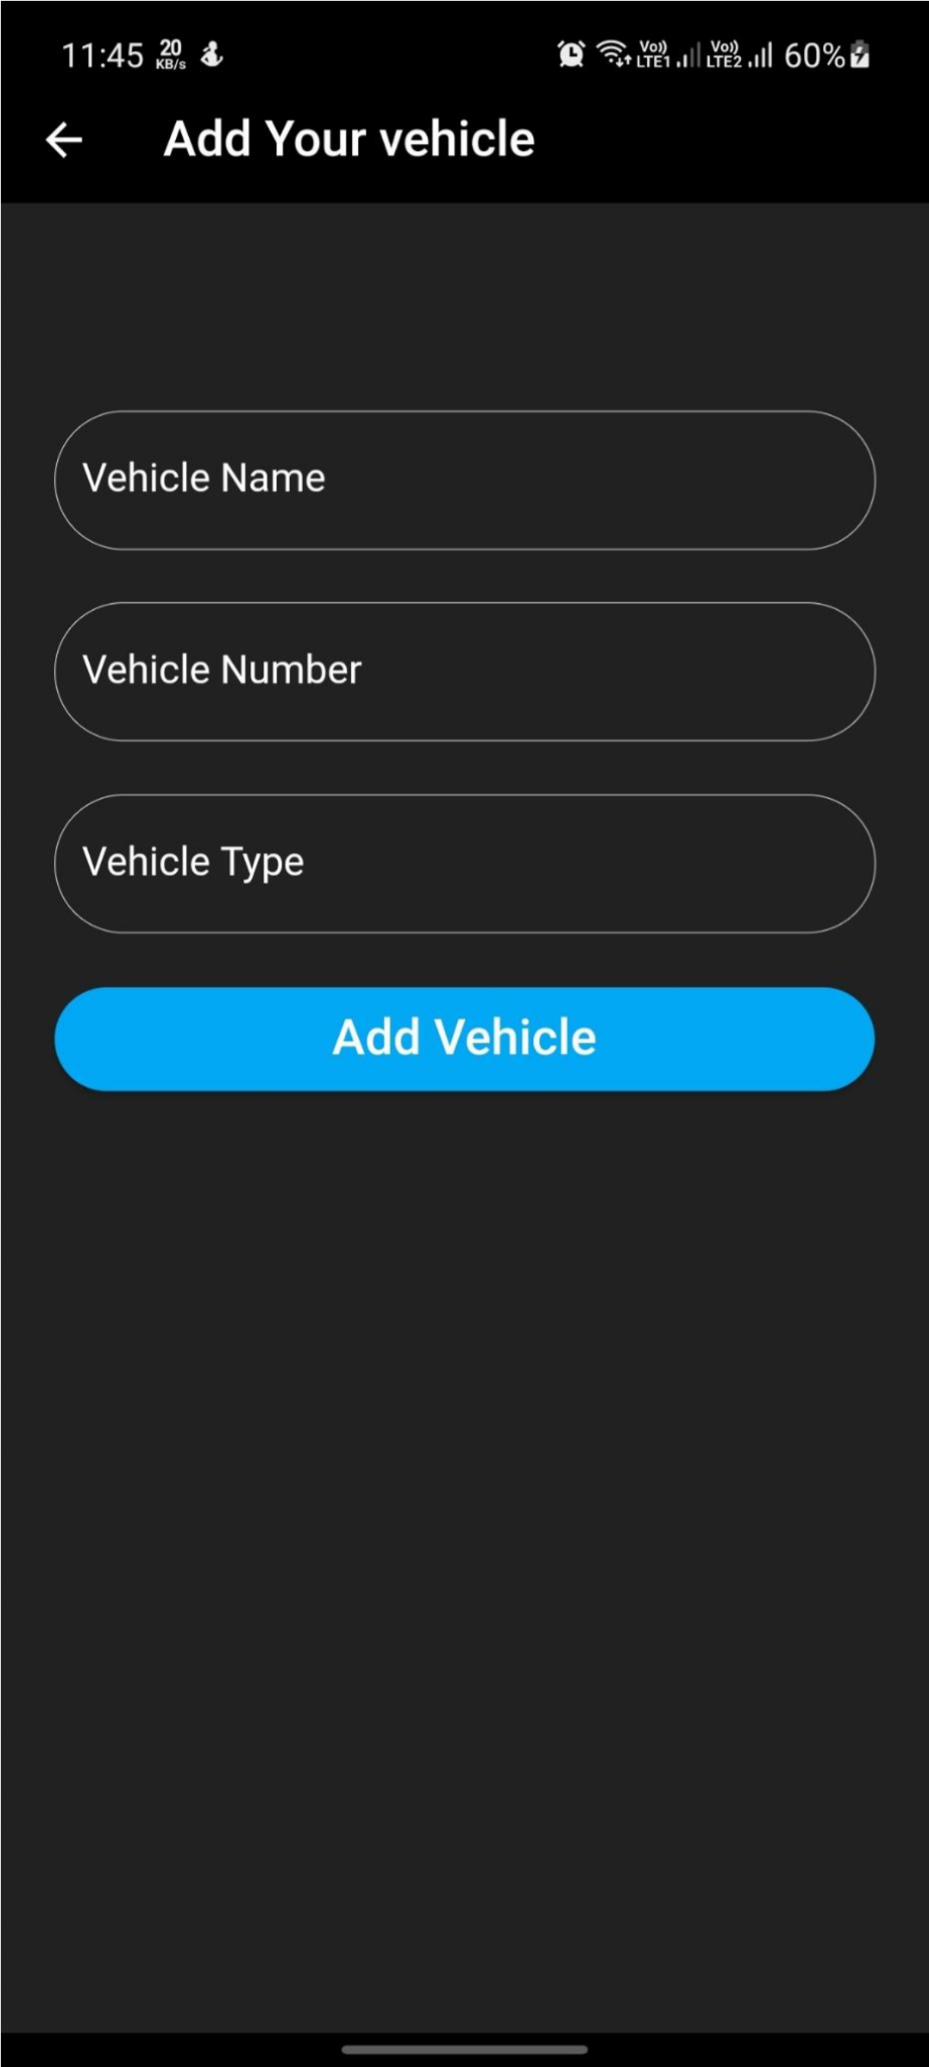

**Admin:-**

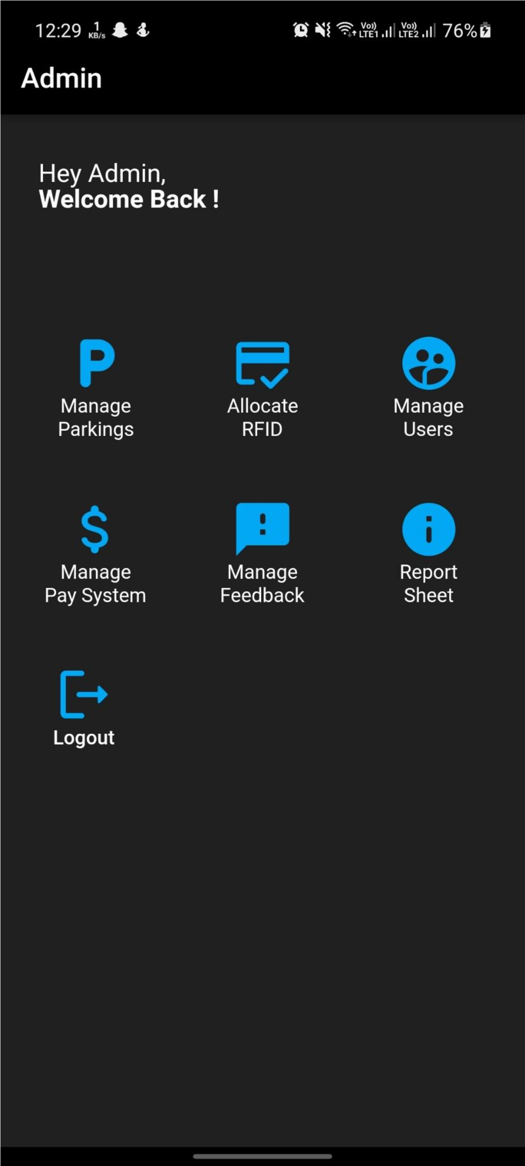

* **Manage Parkings:-**

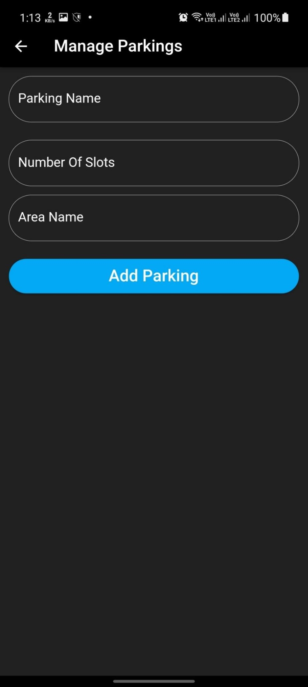

* **Manage Users:-**

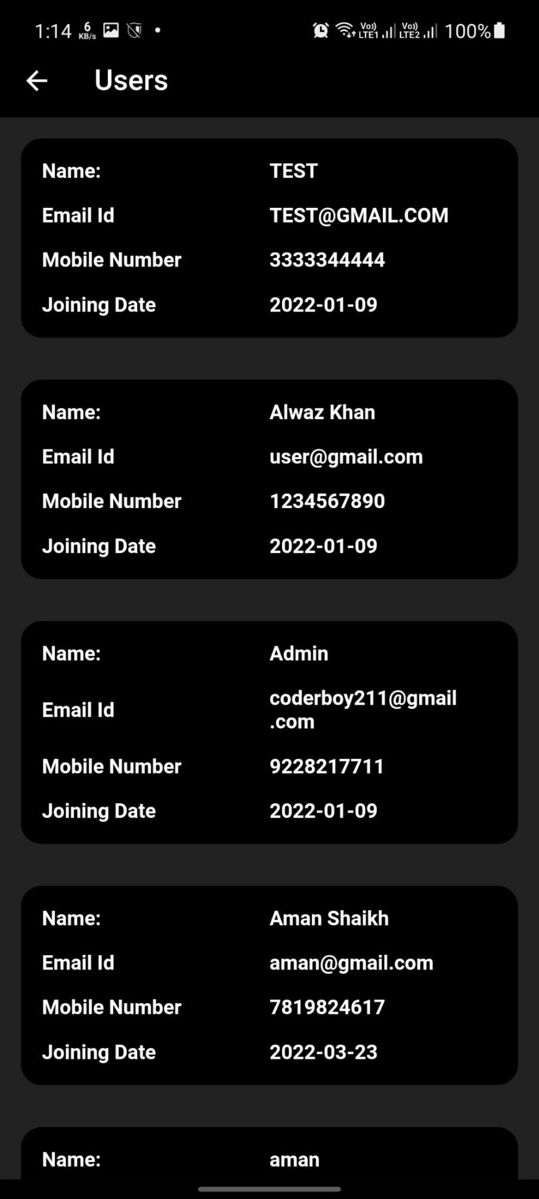

* **Manage Feedback:-**

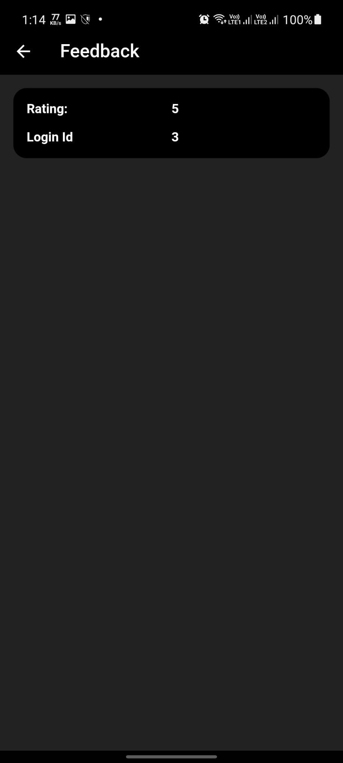

**Report layouts**

* **Report Sheet:-**

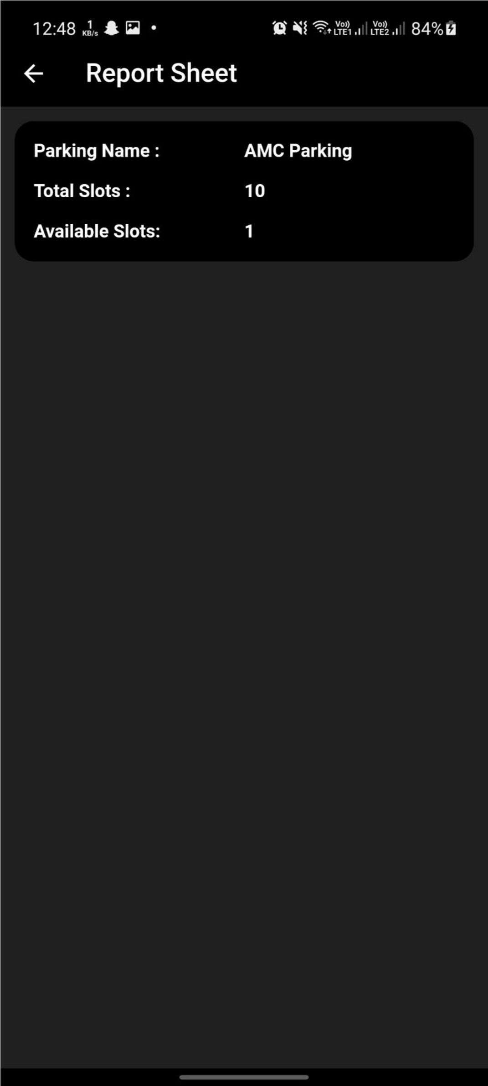

**FUTURE ENHANCEMENT**

* + We can add payment getway to pay directly whenever any car or vehicle exits from parking slot.
  + So they can pay easily from mobile application only.
  + We can add one more feature in future which shows near by free parking slot according to your location.
  + Which helps user to find slot easily and it will also save lot of time and energy.

**CONCLUSION**

IOT based Smart parking system is efficiency in alleviating the traffic problem that arise especially in the city area where traffic congestion and the insufficient parking space are undeniable. Parking vehicles is a task that takes lots of time and effort. Our SMART PARKING SYSTEM project is planned to be integrated with another application to help users to find the empty space through displaying slot on website with less time. Developing a Smart Parking System within a city is help to solving half traffic issue. Our Smart Parking

System helps to solving all traffic issue that cause of parking and it takes less. It’s a Fast, Time consuming, Effortless and systematic parking system.

**BIBLIOGRAPHY**